Graduation Project Documentation:
Week 1:
Studying and preparing Dataset UNSW-NB15
https://www.kaggle.com/datasets/harshwardhanbhangale/unsw-complete-dataset
Understanding the Attack Types in the dataset:
The UNSW-NB15 dataset categorizes attacks into nine specific types. Here is a simple explanation of what each one is.

1. 🎯 Fuzzers
- What it is: This is like a "stress test" used by attackers.
- Analogy: Imagine aggressively shaking a vending machine and pressing all the buttons at once, just to see if you can break it or get a free soda.
- Technical Explanation: An attacker sends a massive amount of random or unexpected data to a program, hoping to crash it and discover a vulnerability.
2. 🕵️ Reconnaissance
- What it is: This is the "spying" or "information gathering" phase.
- Analogy: A burglar casing a neighborhood to find houses with unlocked doors, open windows, or weak security systems.
- Technical Explanation: The attacker actively scans your network to see which ports are open, what services are running, and what IP addresses are active.
3. 💣 Exploits
- What it is: The "break-in" itself.
- Analogy: The burglar, having found an unlocked window during reconnaissance, now actually opens the window and climbs inside.
- Technical Explanation: The attacker uses a specific piece of code (an "exploit") that takes advantage of a known vulnerability (a "bug" or flaw) in your software to gain access or run their own code.
4. 🚫 DoS (Denial of Service)
- What it is: Overwhelming a service so it can't help real users.
- Analogy: Thousands of fake customers creating a massive line in front of a store, blocking the door so real customers can't get in.
- Technical Explanation: An attacker floods a server or website with so much "junk" traffic (like connection requests) that it gets overwhelmed and can't respond to legitimate users, effectively shutting it down.
5. 🔓 Backdoors
- What it is: A secret way back into a system.
- Analogy: After breaking in, the burglar installs a secret lock on a back door so they can come and go as they please without being noticed.
- Technical Explanation: A method for bypassing all normal security and authentication. It can be a hidden piece of code left by an attacker (after an Exploit) or a vulnerability they discovered.
6. 🦠 Worms
- What it is: Self-spreading malware.
- Analogy: A "zombie" that bites one person, who then turns into a zombie and goes off to bite others, spreading the infection automatically.
- Technical Explanation: A piece of malware that replicates itself and spreads to other computers on the network on its own, usually by exploiting a vulnerability.
7. 📜 Shellcode
- What it is: The attacker's "instructions" that run after a break-in.
- Analogy: The to-do list the burglar follows after climbing through the window (e.g., "1. Go to the safe, 2. Steal the jewelry, 3. Unlock the back door").
- Technical Explanation: This is the small piece of code (the "payload") that an Exploit delivers. Its job is to give the attacker a "shell" or command prompt on the victim's machine, giving them full control.
8. 🔎 Analysis
- What it is: A deeper, more advanced form of spying.
- Analogy: Instead of just looking at houses, the burglar taps the phone lines or analyzes power usage to understand the family's schedule and habits.
- Technical Explanation: This category involves more passive and in-depth analysis, such as sniffing traffic to intercept data, analyzing code, or cryptographic analysis.
9. 🔑 Generic
- What it is: A catch-all for "brute force" style attacks.
- Analogy: Trying every single possible key on a key ring until one finally opens the lock.
- Technical Explanation: This refers to attacks that work against a class of systems, not a specific vulnerability. In this dataset, it often refers to brute-force attacks against cryptographic systems (like trying to guess a password or key).

Understanding the features:
The dataset contains 49 features. In the NUSW-NB15_features.csv file.
The NUSW-NB15_features.csv file is your legend or data dictionary. It's the guide that tells you what all the columns in your real data files (like UNSW-NB15_1.csv) actually mean.
You do not train your model on this file. You use this file to understand how to prepare the other files for training.
Here's a simple breakdown of the 49 features, grouped by what they tell you.
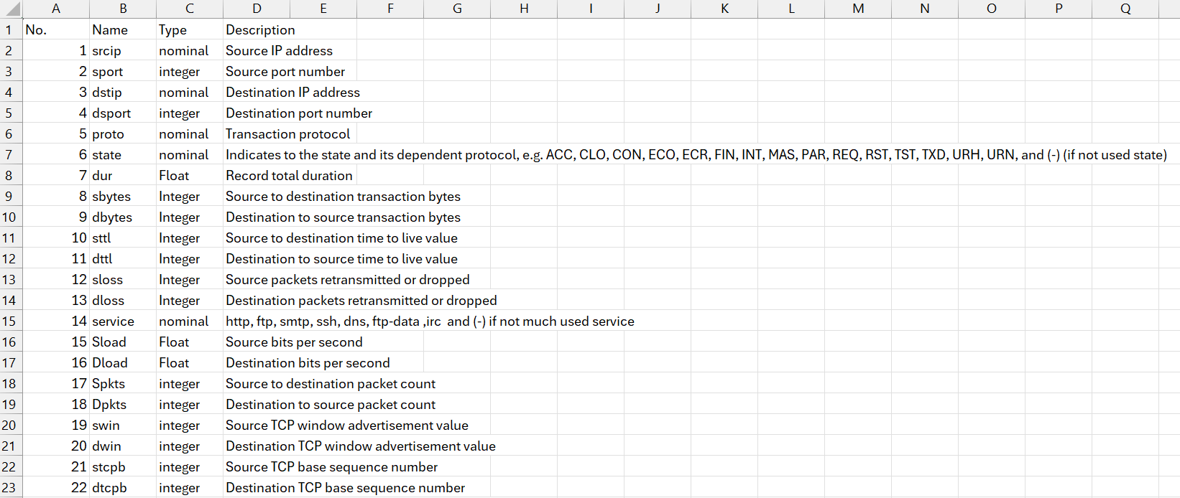
(Snippet of the file)
How to Use This File
The features file has three important columns you've already seen: Name, Type, and Description.
- Name: This is the column header in your data files (e.g., srcip, dur, sbytes).
- Type: This is the most important part for preprocessing.
  - Nominal (or object/categorical): These are text values (like tcp, udp, fin). Your AI model can't read text, so you will need to encode them into numbers (e.g., using One-Hot Encoding).
  - Integer / Float: These are numbers. You will need to scale them (e.g., using Standardization or Normalization) so that one feature (like sbytes) doesn't overpower another (like spkts).
- Description: This tells you in plain English what the feature is, which helps you understand why your model might find it important.

The 49 Features, Grouped
Here are the features broken down into simple categories:
1. Basic Connection Features (The "Who, What, Where")
These are the most basic facts about the connection.
- srcip, dstip: Source IP and Destination IP (Who is talking).
- sport, dsport: Source Port and Destination Port (Which "door" they used).
- proto: The protocol (e.g., tcp, udp).
- service: The service used (e.g., http, ftp, dns).
2. Flow & Packet Count Features (The "How Much")
This group counts the bytes and packets. A sudden flood of bytes is a classic attack sign.
- dur: Total duration (time) of the connection.
- sbytes, dbytes: Source bytes and Destination bytes (How much data was sent).
- spkts, dpkts: Source packets and Destination packets (How many packets were sent).
- sloss, dloss: Source and Destination packets lost.
3. Connection State Features (The "How")
This describes the behavior of the connection, like a conversation's tone.
- state: The state of the connection (e.g., FIN means it finished, INT means it was interrupted). This is a very important feature.
- sttl, dttl: Time-to-Live values, which can indicate the path a packet took.
4. Advanced & Time-Based Features (The "Patterns")
These are more complex features calculated about the connection. Don't worry about the exact math, just know they help spot unusual patterns.
- sload, dload: Source and Destination load (data rate).
- sjit, djit: Source and Destination "jitter" (delay consistency).
- smeansz, dmeansz: Mean size of source and destination packets.
- ct_... (e.g., ct_srv_src, ct_dst_ltm): These are "count" features. They count how many recent connections share the same IP, port, or service. They are extremely useful for spotting attacks like port scans or DoS.
5. The "Answer Key" (Your Target Labels)
These last two columns are not features to train on, but are the answers you want your model to learn.
- attack_cat: The specific category of the attack (e.g., Fuzzers, DoS, Reconnaissance, or Normal).
- label: The simple, binary answer. 0 = Normal, 1 = Attack.
For our project, we will use all the other features (1-47) to predict the label (column 49).
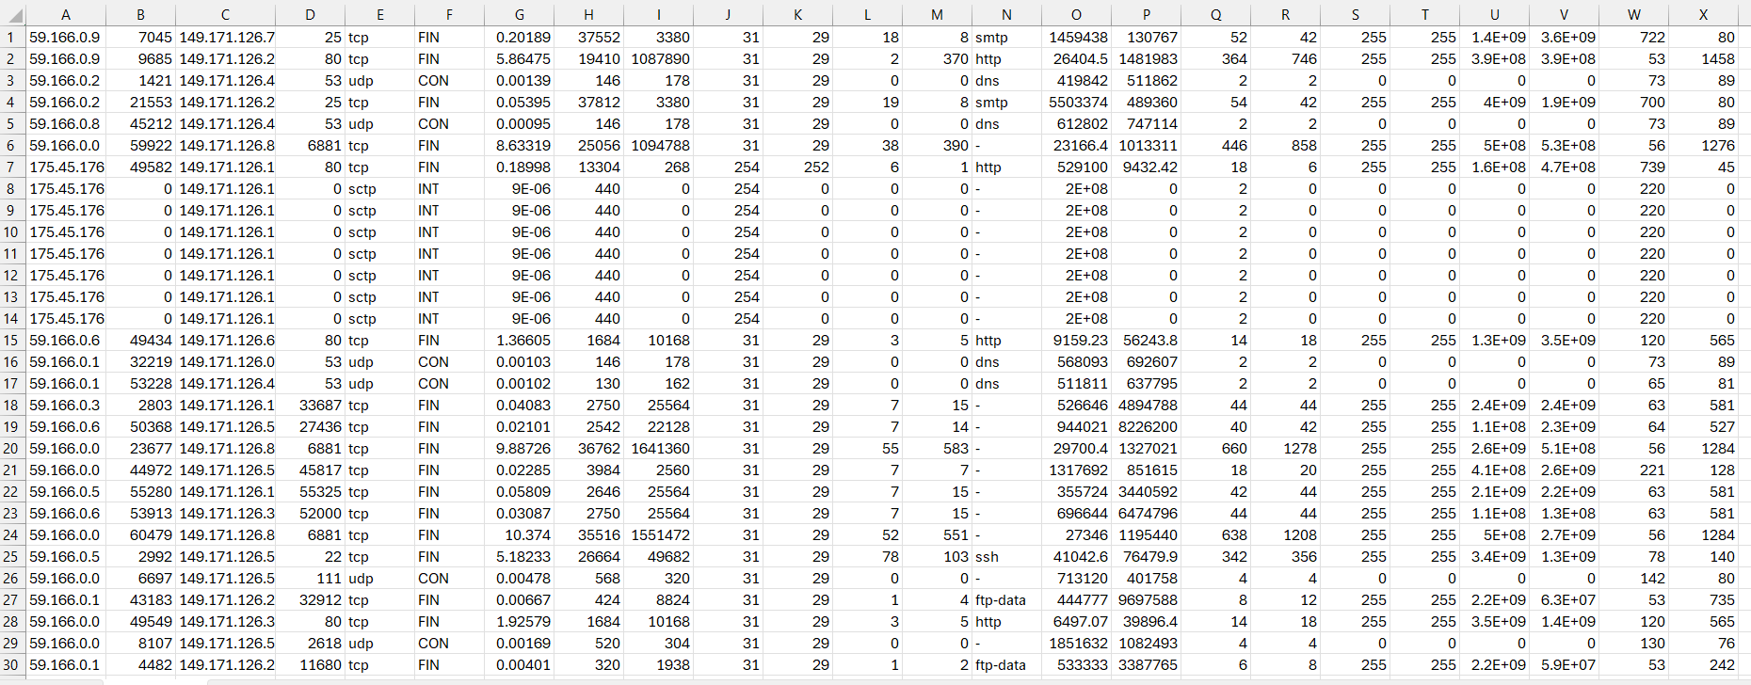
(Snippet of the first 24 features in the reat dataset)
Take the first row for an example,
Feature 1: “srcip” the Source IP is = 59.166.0.9
Feature 2: “sport” Source Port is = 7045
Feature 3: “dstip” the Destination IP is = 149.171.126.7
Feature 4: “dsport” Destination Port = 25
Feature 5: “proto” The Protocol = tcp
and so on…
Understanding the Objective:
These 2 columns are the Objective Columns:
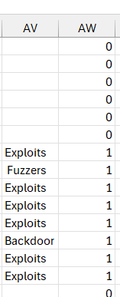
Row 48 the attack type, the model detecting “What kind of attack type this is”.
Row 49 labeling it as Malicious 0 = not malicious, 1 = malicious
Hence why these are the Objective Columns.

